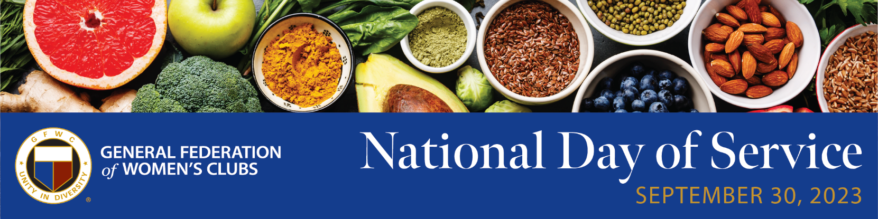
INFORMATION TO START PLANNING
The General Federation of Women’s Clubs (GFWC) is united in its dedication to volunteer community service. The National Day of Service (NDS) is a day in which all of GFWC comes together in service to highlight an area of need, take action to address the need, and raise public awareness about its importance. State federations and clubs are encouraged to join in and organize community service programs (CSPs) in their communities as part of the NDS. It’s also a great opportunity to invite guests to participate in your NDS activities and introduce them to the benefits of GFWC.
This year’s NDS issue of focus is food insecurity. To initiate the planning process, GFWC encourages you to contact your local food banks and food pantries — wherever people go for food — to find out how best to be of service. For example, a club can sponsor a food bank, pantry, or food program to organize a volunteer activity with fellow club members, family, and friends. Ask every member of your club to invite a friend who is not presently a member to participate and experience GFWC in action. Use the activity to motivate and inspire your friend to join. The benefits of community service not only make a person feel good, but it helps to build meaningful friendships and bonds that will last a lifetime.
Here are suggestions for NDS activities:
- Volunteer at a Local Food Bank

- Food Drives: Connect directly with the local food bank to determine how your club can be of service. They will welcome the support and donation of time and food.

- Raise Awareness About Hunger: Reach out to your local media to introduce NDS and the cause being promoted. Ask the reporter to mention NDS and how people can participate and donate. Also, use social media to discuss food insecurity with members of your community, clubs, schools, church groups, and others.

- Advocate to End Food Insecurity: Use GFWC’s Legislative Action Center (LAC) to interact with your federal and state elected officials to advance a bill or introduce legislation that helps to end hunger by funding programs specific to the issue.

Information and updates about NDS will be in the weekly electronic newsletter GFWC News & Notes, Facebook, Instagram, and website, www.GFWC.org. Every week until September 30, GFWC will make announcements, provide project ideas, and discuss food insecurity. Stay tuned for additional resources including a tool kit and a media kit.

Start planning today!
Locate your local food bank and food services at the following links:
Second Harvest - food near me - Second Harvest (2-harvest.org)
Feeding America - Find Your Local Food Bank | Feeding America
Type “food banks (your state)” into your search engine
Find churches with food banks in your state - https://save.lovetoknow.com/Churches_with_Food_Pantries
Find information about food insecurity at the following links:
US Department of Agriculture - https://www.fns.usda.gov/fact-sheet/usda-support-for-food-banks-emergency-food-system
Office of Disease Prevention and Health Promotion - https://health.gov/healthypeople/priority-areas/social-determinants-health/literature-summaries/food-insecurity
National Public Radio, Food Insecurity in the US By the Numbers - https://www.npr.org/2020/09/27/912486921/food-insecurity-in-the-u-s-by-the-numbers

To register or for more information, contact Melanie Gisler, Director of Membership Services, at MGisler@GFWC.org and copy Deb Strahanoski, International President, at DStrahanoski@GFWC.org. Please include the following in your email: Club Name, Point of Contact, Address, Phone Number, and Email. GFWC will send information, articles, and announcements directly to your club.

